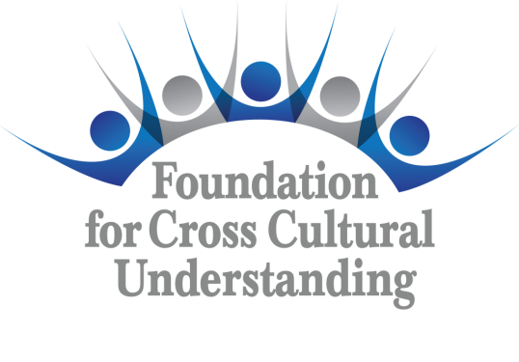 | Waiver Form  Form WAI E-14

(All boxes expand to fit text)

I hereby grant permission to the Foundation for Cross Cultural Understanding to use or publish my image, written or spoken words, artwork, or sound of my voice as recorded on audio or video tape. I understand that my image may be digitized, edited, copied, exhibited, published or distributed and waive the right to inspect or approve the finished product wherein my likeness appears. Additionally, I waive any right to royalties or other compensation arising or related to the use of my image, words, artwork, or recording. I also understand that this material may be used within an unrestricted geographic area.
By signing this release I understand this permission includes any photographic or video recordings of me that may be electronically displayed via the Internet or in a public educational setting. Additionally, I’m aware there is no time limit on the validity of this release.
By signing this form below I acknowledge that I have completely read and fully understand the above release and agree to be bound thereby.
Full Name
Street Address
City
State
Zip Code
E-mail Address

Signature | Date

If this waiver is obtained from an individual under the age of 19, then the signature of the individual’s parent or legal guardian is also required.
Parent or Guardian Signature | Date

