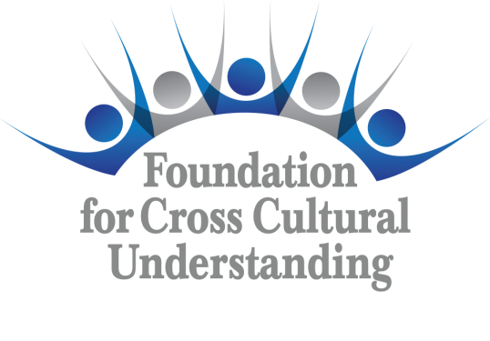 | Foundation  Donation  Form

(All boxes expand to fit text)

I/We | Name | Address | Phone | E-Mail Address

Pledge to donate the following amount:
In honor of, in memoriam of, or other (please state condition/name of person being honored)

to the Foundation for Cross Cultural Understanding (please indicate a sub fund of your choice).

Sarah Ernst Darnall Fund | Scholarship for Humanity | Peter and Vicki Tejada Fund | Jane Van Fleet Fund | Marilyn Oleson Expansion Fund

Use of this gift within the fund noted above is designated as (please indicate below)

Capital (restricted, not to be spent) | Available for Grants

The amount will be transferred by electronic transfer (please indicate bank information) |  | Name of Bank  Address  Account Number

Or by check to the Foundation Treasurer (preferred) |  | Or via CISV USA Chapter or CISV USA National Association

Date/Place | Printed Name and Signature

The Foundation is a 501 (c) (3) non-profit organization: Tax ID Number 31-1390752. Please e-mail or send the completed Foundation Donation Form to the Foundation Treasurer:

Ellen Fowler
407 Drummer Lane
Knoxville, TN 37924
E-mail: treasurer@fccuusa.org

Thank you for your kind thoughtfulness in supporting the work of CISV USA through the Foundation!

