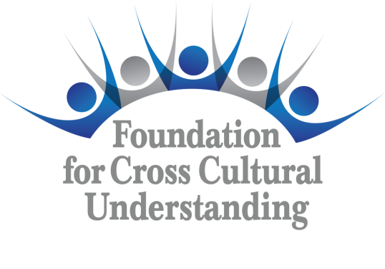 | Grant  Application  Form  Form GA E-14

(All boxes expand to fit text)

Grant Number (To be assigned) | Amount Requested | Date of Application

Grant Title | Chapter/Committee

Contact Person
Address
E-mail
Phone

Please provide an abstract of your proposed project. (Not to exceed 200 words)

Include a budget in the section below showing anticipated revenue and expenditures. Indicate the amount and source of any matching funds.
Expense/Item | Cost

Submit a detailed but concise description of the project below. Explain what you hope to accomplish and how the project will benefit CISV USA, the Chapter/Committee.

Please complete the timetable below indicating when each objective will be completed. Indicate the person(s) responsible for implementing each part of the project. Please indicate the halfway point in your timetable with an asterisk *. This will be the due date for the project’s Midway Grant Report (Form MGR E-14) should your proposal be funded.
Project Objective | Date for Completion | Person Responsible

I accept the following:

- Contact will be maintained with the assigned Foundation liaison. A written report using the Midway Grant Report, Form MGR E-14, must be submitted to the grant liaison with a copy sent to the Foundation Trustees via e-mail addresses contained in Grant Application Procedure on fccuusa.org website.

- Photographs, videos, artwork, and spoken or written testimonial evidence of this project will be collected by the grantee along with all necessary Waiver Forms (WAI E-14) from the individuals involved.

- Upon completion of the project, but no later than 60 days after completion, the Grant Summary Form (Form GS E-14) must be submitted together with a detailed accounting of expenditures including copies of any invoices received, bills paid, and canceled checks. Accompanying the Grant Summary Form and supporting documentation will be a completed Request for Release of Grant Funds (Form RGF E-14).

Signature | Date

Please send a completed Grant Application Form (GA E-14) to grants@fccuusa.org

This section for use by Foundation for Cross Cultural Understanding Trustees only.
 | Grant application is approved.
 |  | Amount | Date
 | Grant application is not approved at this time.
 |  | Reason | Date

