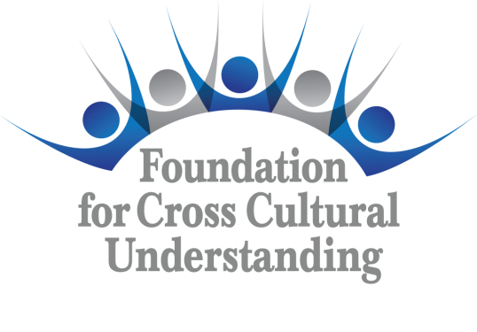 | Grant  Summary  Form  Form GS E-14

(All boxes expand to fit text)

Grant Title | Grant Number | Chapter/Committee | Date of Summary

Contact Person
Address
Telephone
E-mail Address

In reporting on the completed grant project, the following topics must be covered. Additional comments are encouraged.
Description of the Project

Benefits gained for CISV and the Chapter/ Committee

Participation: Number of CISV members involved
Non-CISV contacts: Number of Individuals & Names of Organizations

Publicity: Please attach any clippings or include links to video footage.

Observations and Advice: What worked, what didn’t, why, etc.

Evaluate the success of the project in terms of the objectives accomplished.

Within sixty days of the completion of the project, send this Grant Summary Form (Form GS E-14) and a detailed accounting of expenditures including receipts and any copies of canceled checks to grants@fccuusa.org . Also include a completed Request for Release of Grant Funds (RGF E-14). Please add any copies of photographs, artwork, or written or spoken testimonies from participants along with any completed Waiver Forms (WAI E-14) required of the individuals featured.

