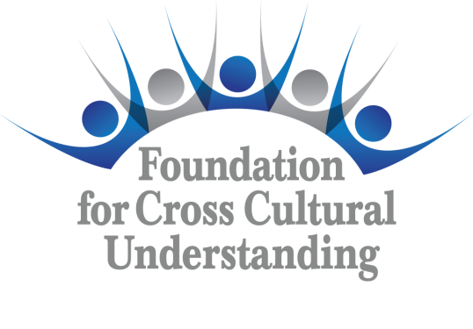 | Request for Release  of Grant Funds  Form  Form RGF E-14

(All boxes expand to fit text)

Grant Title | Grant Number | Chapter/Committee | Date of Request

Contact Person
E-mail Address
Phone

Send Foundation check to:
Name
Position
Mailing Address

Amount Requested | $
Amount Approved | $

Signature of Contact Person | Date

Send this Request for Release of Grant Funds Form (Form RGF E-14) along with a completed Grant Summary Form (Form GS E-14), copies of supporting documentation, and any Waiver Forms (WAI E-14) required of individuals featured in photos, videos or other project evidence to grants@fccuusa.org. If approved by the Board of Trustees, the Treasurer for the Foundation for Cross Cultural Understanding will release the grant funds within 10 business days.

